# LAB 2: Non Linear Curve Fitting

**THEORY:** As we know that given the values of two parameters at different time points, finding relation between them is an important task. The relation need not be always linear. So here we look into some types of non linear curves and the normal equations using the principle of least squares.

Fitting a parabola: Let *y= ax2 + bx + c* be a parabola. To fit a parabola, the normal equations are

$$Σx^{2}y=aΣx^{4}+bΣx^{3}+cΣx^{2}$$

$$Σxy=aΣx^{3}+bΣx^{2}+cΣx$$

$$Σy=aΣx^{2}+bΣx+nc$$

Fitting a exponential curve: Let *y= aebx* be a exponential curve. To fit it, the normal equations are as follows:

Let $Y=\log_{10}{y} ,A=\log_{10}{a}, B={b log}_{10}{e}.$ Then

$$ΣY=nA+BΣx$$

$$ΣxY=AΣx+BΣx^{2}$$

Fitting a logarithmic curve: Let *y= axb* be a logarithmic curve. To fit it, the normal equations are as follows:

Let $Y=\log_{10}{y} ,A=\log_{10}{a}, X=\log_{10}{x}.$ Then

$$ΣY=nA+bΣx$$

$$ΣXY=AΣX+bΣX^{2}$$

By solving the normal equations, the coefficients are obtained.

One can compute R square value. It is a measure of goodness of fit. If R square value is closer to 1, it implies fit is very good whereas if the value is closer to 0, it implies the fit is not good.

**Ex. 1:** Fit a parabola y = ax2+bx+c in least square sense to the data. Does a better relation exists?

|  |  |  |  |  |  |
| --- | --- | --- | --- | --- | --- |
| x | 10 | 12 | 15 | 23 | 20 |
| y | 14 | 17 | 23 | 25 | 21 |

PROCEDURE:

* Go to files, open a new EXCEL workbook
* Enter the data in the workbook
* Compute ∑x = sum of Xis by typing =SUM(select all the cells containing x values), press ENTER.
* Compute ∑x2 = sum of Xi2s by typing =SUMPRODUCT(select all the cells containing x values, select all the cells containing x values), press ENTER
* Compute ∑x3 = sum of Xi3s by typing =SUMPRODUCT(select all the cells containing x values, select all the cells containing x values, select all the cells containing x values), press ENTER
* Compute ∑x4 = sum of Xi4s by typing =SUMPRODUCT(select all the cells containing x values, select all the cells containing x values, select all the cells containing x values, select all the cells containing x values), press ENTER
* Compute ∑y= sum of Yis by typing =SUM(select all the cells containing y values), press ENTER.
* Similarly compute ∑xy, ∑x2y
* The two normal equations are as follows:

. $$Σx^{2}y=aΣx^{4}+bΣx^{3}+cΣx^{2}$$

$$Σxy=aΣx^{3}+bΣx^{2}+cΣx$$

$$Σy=aΣx^{2}+bΣx+nc$$

This can be written in the matrix form as

$$\left[\begin{matrix}Σx^{4} & Σx^{3} & Σx^{2} \\ Σx^{3} & Σx^{2} & Σx \\ Σx^{2} & Σx & n\end{matrix}\right]\left[\begin{matrix}a \\ b \\ c\end{matrix}\right]=\left[\begin{matrix}Σx^{2}y \\ Σxy \\ Σy\end{matrix}\right]$$

* Type normal equation in matrix form in the excel
* Value of a, b, c are obtained by multiplying inv(coeff) to value matrix.

So, the inverse of the matrix is calculated by the given formula

* First select the cells where the inverse has to be entered.
* Then type in formula bar =MINVERSE(select the matrix whose inverse has to be computed) Then press CTRL+ SHIFT+ENTER
* Therefore by multiplying inverse matrix by value vector, we get a, b, c.
* First select the cells where the value of a, b and c has to be evaluated
* Then type in formula bar =MMULT(select the inverse, select the value matrix) Then press CTRL+SHIFT+ENTER
* Therefore the required equation is y= -0.0695 x2+3.0099 x-8.7279 (See Fig 2.1.1)

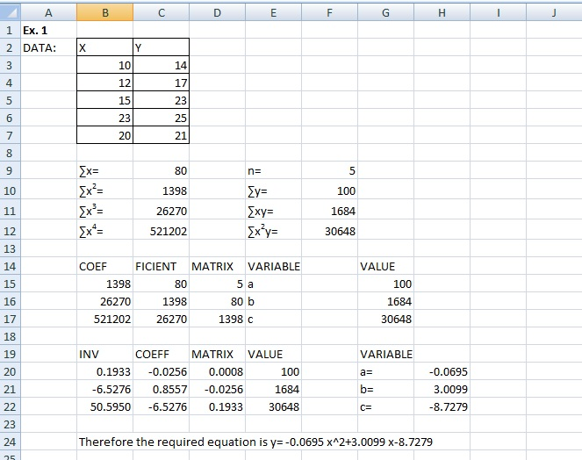**Fig2.1.1**

* Select cells under x and y. Then in insert tab choose scatter plot.
* Select any data point in the scatter plot and right click then in the pop up window choose Add Trendline as shown in the Fig 2.1.2

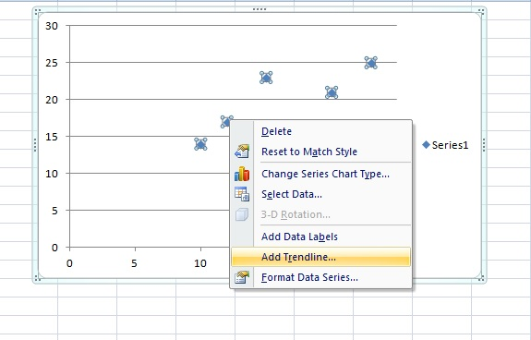

**Fig 2.1.2**

* A new pop up window comes up. In that first choose exponential. Also tick in ‘Display equation on chart’ and ‘Display R- squared value on chart’. Then select line color.

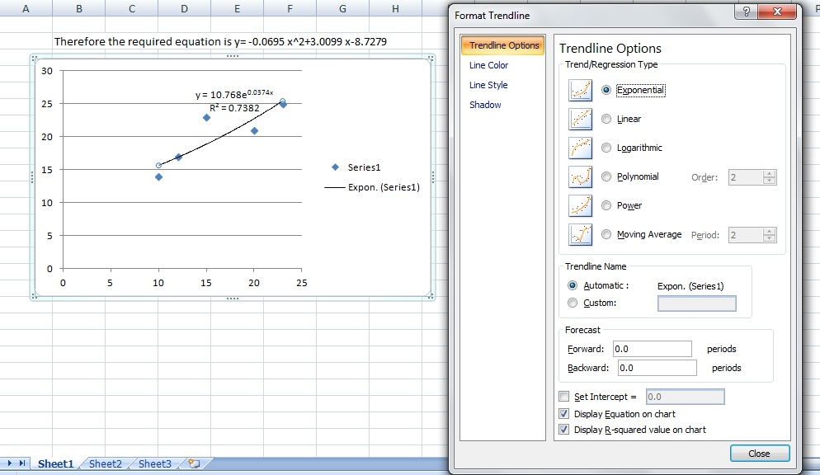

**Fig 2.1.3**

* In Line Color, choose solid line. In drop down menu for color, choose blue color for the trendline.

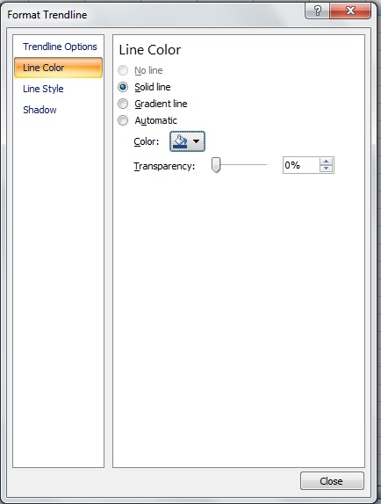

**Fig 2.1.4**

* Drag the equation to the side.
* Then again click any data point and right click. Choose ‘add trendline'. In Format trendline, select linear trendline. Again tick in ‘Display equation on chart’ and ‘Display R- squared value on chart’. Then select line color. Choose black color and close. Drag the equation to the side.
* Repeat the same and plot logarithmic trendline. Choose green color and drag the equation to the side.
* Similarly, select polynomial trendline, choose degree 2 and plot. Then select color red for it and adjust the equation placement. This is nothing but the parabolic fit. So, compare the equation in the graph and the one obtained using normal equations. It should be the same.
* Repeat the same and plot power law trendline. Choose purple color and drag the equation to the side.
* Compare the R square value of each fit to test goodness of fit. In this case, both parabolic and power law explains the data more than other fits as R square is more.

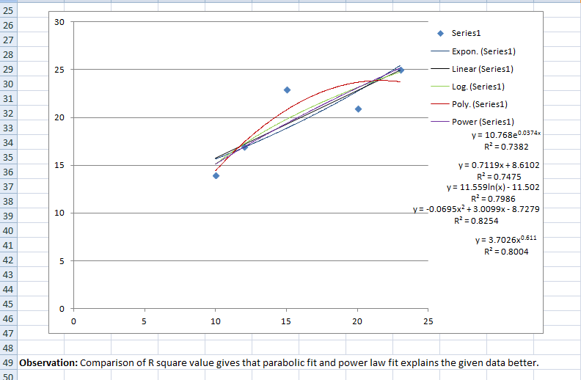

**Fig 2.1.5**

**Ex. 2:** The following table gives the result of the measurements of train resistances. V is the velocity in miles per hour. R is the resistance in pounds per ton.

|  |  |  |  |  |  |  |
| --- | --- | --- | --- | --- | --- | --- |
| V | 20 | 40 | 60 | 80 | 100 | 120 |
| R | 5.5 | 9.1 | 14.9 | 22.8 | 33.3 | 46.0 |

Find a, b, c if R is related to V by the relation R= aV2+bV+c. Does a better relation exists ?

**Ex. 3:** The voltage V across the capacitor at time t seconds is given by the following table. Use the principle of least squares to fit a curve of the form V= aebt.

|  |  |  |  |  |  |
| --- | --- | --- | --- | --- | --- |
| t | 0 | 2 | 4 | 6 | 8 |
| V | 150 | 63 | 28 | 12 | 5.6 |

Check if it is the best form of curve**.**

**Ex. 4:** The pressure and volume of a gas are related by the equation pvg = k, g and k being constants. Fit this equation to the following set of observations:

|  |  |  |  |  |  |  |
| --- | --- | --- | --- | --- | --- | --- |
| p (kg/cm2) | 0.5 | 1.0 | 1.5 | 2.0 | 2.5 | 3.0 |
| v (litres) | 1.62 | 1.00 | 0.75 | 0.62 | 0.52 | 0.46 |

Check if it is the best form of curve.